Safe Hands Patient app mobile screens

Menu options

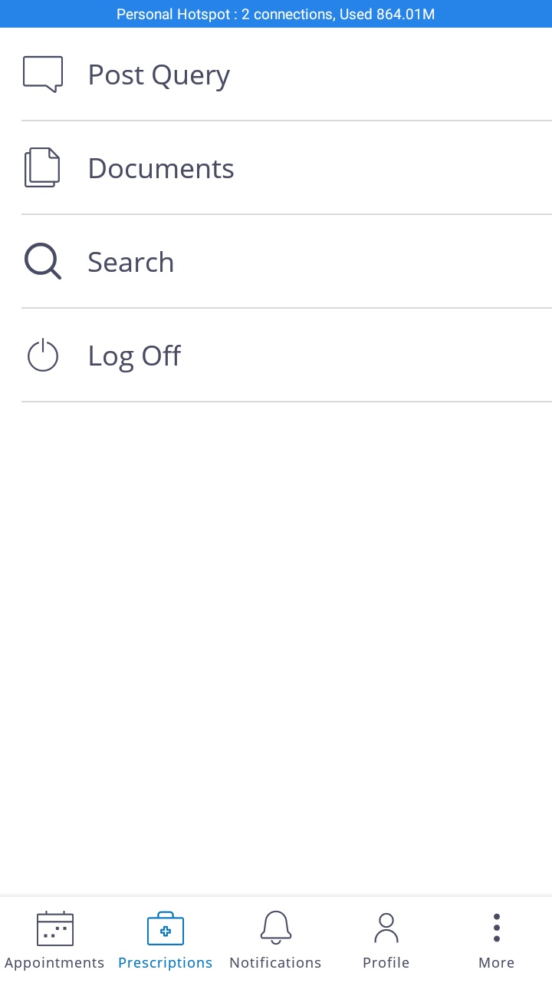

Appointments Screen: It will show Scheduled/Cancelled/Completed appointments of particular patient. He can Reschedule/ Cancel his appointment on Edit Scheduled appointments.

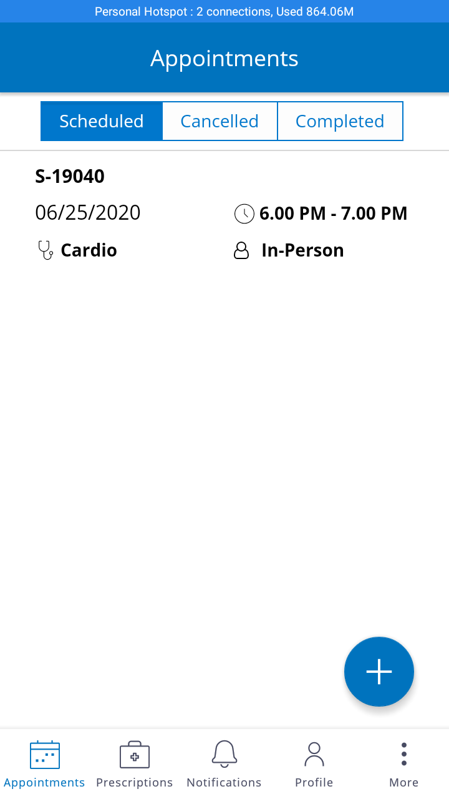

**Edit Appointment:**

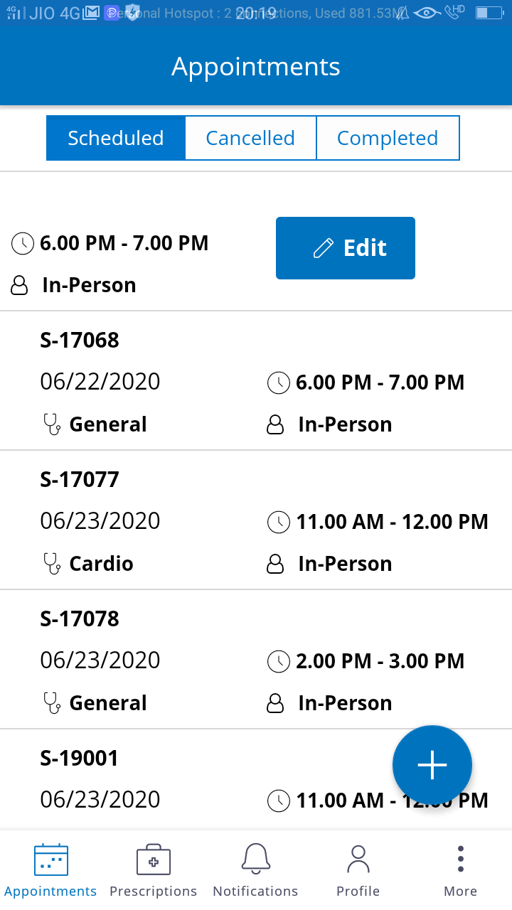

**Create Appointment**: FAB Icon on Appointment screen will allow you to create new appointment

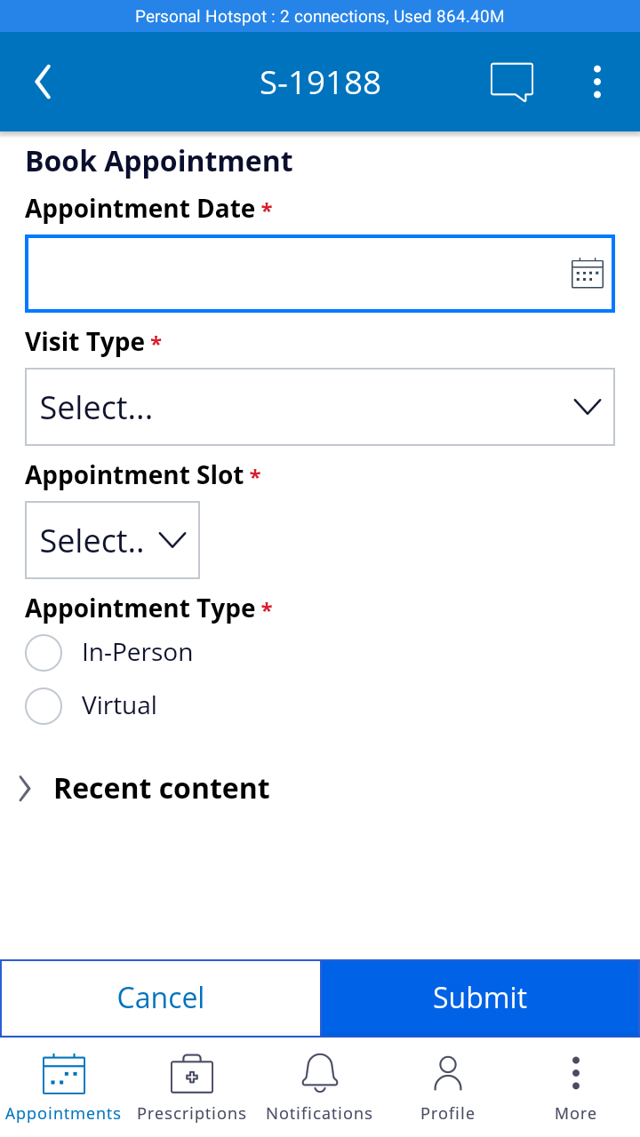

**Prescription Screen:** This screen will display all prescription details of Today/Next/Past data.

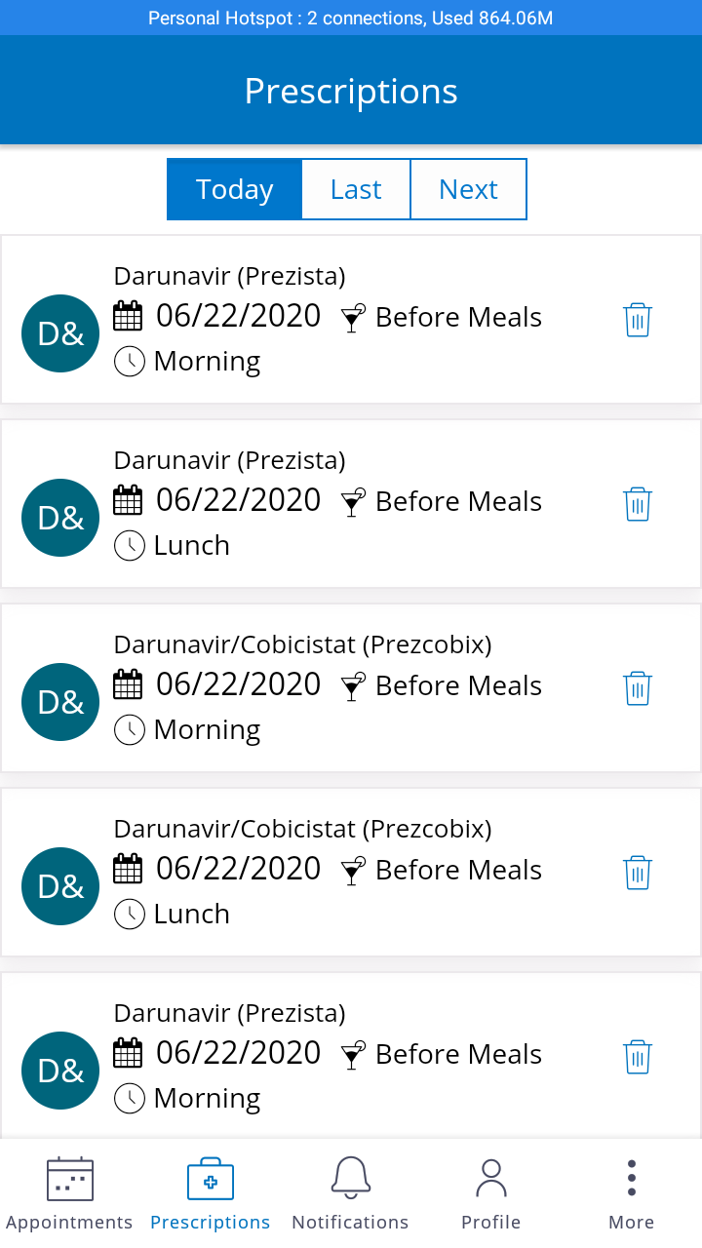

**Profile:** Profile screen will display Patient details and it allows him to update notification preferences and personal data aswell.

